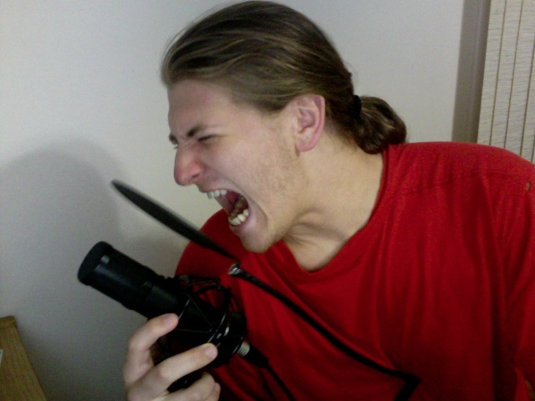
Richard Garner, a Rock Star voice actor
E-mail : rgvoiceact@yahoo.com
Website: http://rlfhog3.newgrounds.com/ or http://tinyurl.com/rgvoiceact
Accents: American, Transylvanian, British, French, Greek, Russian… more or less anything.
Examples of productions Richard has had his voice in:

The Gilnean Fallow (A Prologue), as “Weston Ashmore”
http://www.youtube.com/watch?v=1b9FWeEodBw

Faces of Cataclysm III preview, as “Silverlace” (the second voice)
http://www.youtube.com/watch?v=JMQekbH170Q&feature=channel_video_title
One Drop of Blood, as “Damien”
http://www.sendspace.com/file/g7mvkb
The Swamp, As “Blake”
http://tinyurl.com/3qb7w8s

Bio: Richard Garner is an aspiring voice actor that specializes in strange and unique voices. He is a 4th year student at Middle Tennessee State University where he is majoring in Audio Technology while tackling three minors: Music, Theatre, and Japanese. Richard does all his own recording in the confines of his one bedroom apartment where he edits the audio and assures that that there is no background noise before sending it off. He prides himself on his deep sultry voice as well as the ability to make himself sound like an old woman. Richard has been voice acting semiprofessionally for two and a half years but really, has been making funny voices and doing weird things with his voice all his life. He hopes to break through into the real voice acting industry at some point in his life, but until then, will continue providing his voice where it is wanted and spreading his name around.

Vocal range: Richard can do any voice from a deep low voice which may belong to the main hero or the villain, to higher crazier voices which may belong to someone in an insane asylum or someone who should most certainly be there. He also dabbles in female voices. Currently, he’s restricted to old ladies and witches but he is working on expanding his range to include middle aged and younger women. With enough practice, it should become believable.

Feel free to contact Richard regarding voice acting for your projects! He would very much appreciate it.

